### 

### TITLE:IOT VIRTUAL DOCTOR ROBOT

**DEPARTMENT OF ELECTRONICS & COMMUNICATION ENGINEERING**

**INNOVATE 2K23**

**Date: 19-04-2023**

**A MINI PROJECT REPORT**

***Submitted by***

|  |  |
| --- | --- |
| **MEHJABEEN TABASUM.M** | **113320106026** |
| **THARANI.P** | **113320106044** |
|  |  |

**Sivarathanabala.M**

**PROJECT GUIDE SIGNATURE**

**ABSTRACT**

Due to less availability of doctors in every hospital where doctors are usually needed for an emergency situations or to monitor the patients, it creates a major impact in patient's life. To resolve this issue a virtual doctor robot is developed where the doctor could be connected to the patient virtually and monitor the patients.

**INTRODUCTION**

The evolution of modern medicine led each one of us to reap the benefits of science and medicine all around the world. Even though there are less physicians available in every hospital where they are usually needed for an emergency situations or to monitor the patients, it creates a major impact in patient's life. To resolve this issue a virtual doctor robot is developed where the doctor could be connected to the patient virtually and monitor the patients.

**NEED FOR THE PROJECT**

A Virtual Doctor system that enables an expert to essentially roam about any clinic space and have spoken conversation with patients helps with this problem. Such robots are used in healthcare settings to ensure assistance and to reduce individual-to-individual interaction.

**PROPOSED WORK**

In this Arduino project, we will create a WiFi controlled robot using an ESP8266 WiFi module, Motor Driver shield, Arduino Uno, 4WD Car chassis, and a battery pack. We will use a free-to-use Android application called Blynk to control the robot effectively by using ESP8266 WiFi module with Arduino to communicate with the Android app over WiFi. This is an efficient way to control the robot rather than using voice commands because WiFi control has 100% accuracy.

Arduino Uno R3 does not support WiFi capabilities hence we have to use a separate WiFi module to enable WiFi connectivity. Therefore, we will interface and program ESP-01 WiFi module with Arduino to enable WiFi features. We will use Arduino IDE to program our Arduino with ESP-01. AT commands through the serial port that is UART will be used to configure the ESP-01 WiFi module.

**BLOCK DIAGRAM**

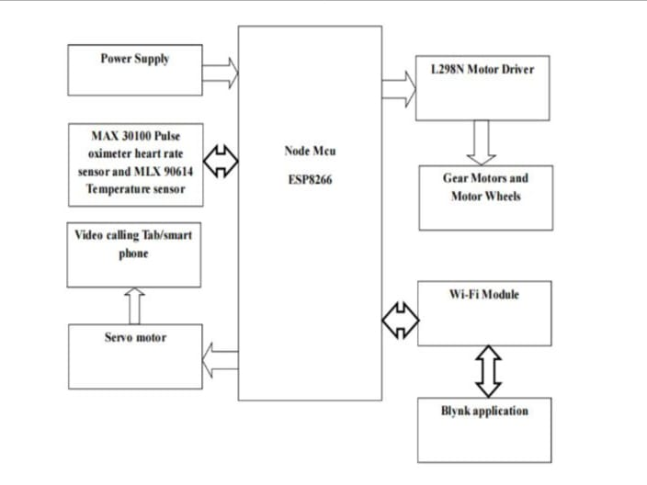

**FUNCTIONS OF EACH BLOCK**

* **Arduino Uno:**Arduino Uno is perfect for this project because it is compatible with the motor driver shield and it also provides 3.3v to power the ESP8266 WiFi module. It is also cheap, easy to use and consumes less space so everything will place on the car chassis.
* **L298 Motor Driver Shield:** The motor driver shield is based on two L293D and 74HC595 IC’s. L293D is a quadruple Half H-driver. It can deliver up to 1 amp per channel. It has a wide supply voltage range (4.5 to 36 volts) and can operate from 0 to 70 degree centigrade. 74HC595 is 8-bit Shift Register with 3-state output registers. This motor driver shield is used to operate DC motors, Stepper motors and servo motors. It can operate 2 servo motors and 4 DC motors simultaneously.
* **4 wheel car chassis:** The 4 wheels car chassis has 2 platforms, 4 tires, 4 geared Dc motors and 4-speed encoders. It provides much space to place everything on chassis but it has a very brittle material which breaks with very less impact. Be careful when assembling the car chassis.
* ****ESP8266 WiFi module**:** ESP8266 is a WiFi chip that provides Transfer Control Protocol (TCP) and Internet Protocol (IP). There are different ESP8266 modules available in the market. In this project, we will use ESP-01. It has 6 pins and operates on 3.3v.
* ****Battery Pack**:** We will use three li-ion 3.7V and 2200mA cells in series to increase the voltages. These cells are rechargeable.They have about 1000 life cycles

**COMPONENTS USED:**

* L298 Motor Driver Shield **.**
* Arduino Uno.
* 4 wheel car chassis.
* ESP8266 WiFi module.
* Battery Pack.
* Jumper wires.
* Tab holder.

**Hardware/Software Details:**

|  |  |
| --- | --- |
| **Hardware** | **Software** |
| Arduino uno | Arduino IDE |
| ESP8266 wifi module | Blynk app |

**RESULT/OUTPUT:**

As per our project due to the availability of the doctor we are using the virtual doctor robot there fore it monitors the patients and help them to make the conversations with patients and clarify their needs.

**Applications:**

* This IoT based virtual doctor robot allows the doctor to move around virtually on their own, without being present at that location.
* Along with making movements, the doctor can talk to patients at different locations. This system consists of a robotic motor vehicle which has four wheels for easy movement.

**CONCLUSION:**

The goal of offering this IoT-based virtual doctor robot is to allow a doctor to virtually walk around at whim in a faraway place and even talk to people there if wanted. This robot offers a number of benefits to doctors, including the possibility for doctors to be anywhere at any time. Doctors are free to walk around in operating rooms. Doctors can easily move about the patient. Doctors can view medical reports via video conversations from afar. The goal of the Virtual Doctor Robot is for it to be able to move around virtually in almost any location, including hospitals, health centers, and operating theatres, keeping doctors safe from contagious diseases like COVID-19. Thus this helps to achieve all these above goals which leads to betterment of our society.

**REFERENCE:**

[1] M. J. Thomas, V. Lal, A. K. Baby, M. Rabeeh VP, A. James, and A. K. Raj, "Can technological advancements help to alleviate COVID-19 pandemic? a review," Journal of Biomedical

[2] D. Koh, "Occupational risks for COVID-19 infection," Occupational Medicine, vol. 70, no.1, pp. 3–5, Mar. 2020, doi: 10.1093/OCCMED/KQAA036.

[3] Shoena Wotherspoon and S. Conroy, "COVID-19 personal protective equipment protocol compliance audit," Infection, Disease & Health, Jun. 2021, doi: 10.1016/J.IDH.2021.06.002.

[4] S. (Sam) Kim, J. Kim, F. Badu-Baiden, M. Giroux, and Y. Choi, "Preference for robot service or human service in hotels? Impacts of the COVID-19 pandemic," International Journal of Hospitality Management, vol. 93, p. 102795, Feb. 2021, doi: 10.1016/J.IJHM.2020.102795.

[5] Han, Y. and Chai, Y.T. (2011) The Architecture Reference of Flexible Supply Chain Simulation System. Journal of System Simulation, 6, 1270-1278.

[6] S. C. Herring, Telepresence Robots for Academics, ASIST 2013, November 1-6, 2013, Montreal, Quebec, Canada.

[7] M. A. Goodrich and A. C. Schultz, “Human–robot interaction: A survey,” Foundations and Trends in Human–Computer Interaction, vol. 1, no. 3, 2007.

[8] P. M. Vespa, C. Miller, X. Hu, V. Nenov, F. Buxey, N. A. Martin, “Intensive care unit robotic telepresence facilitates rapid physician response to unstable patients and decreased cost in neurointensive care,” Surgical Neurology, vol. 67, 2007, pp. 331 – 337.

**PHOTO OF PROJECT:**

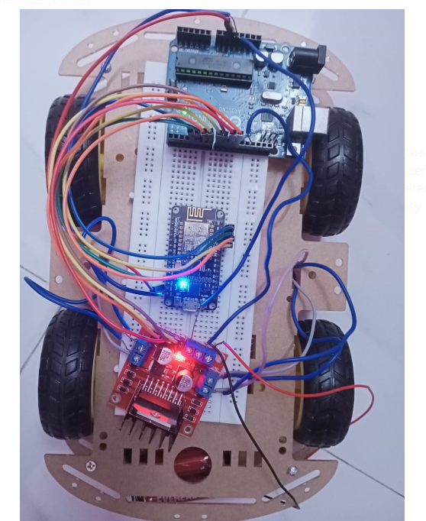

**PHOTO OF TEAM MEMBERS WITH GUIDE:**

